1.Read FairDealCustomerData.csv

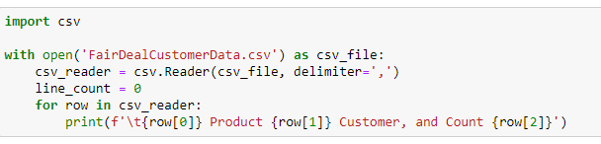

2. Name field contains full name –use regular expression to separate title, first name, last name

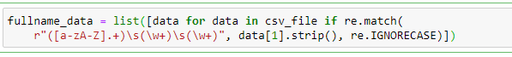

3. Store the data in Customer Class

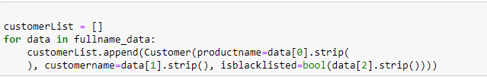

4. Create Order to take product name and product code as input

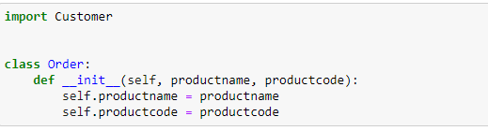

5. Pass a customer to function "create Order" and throw Customer Not Allowed Exception in case of blacklisted value is 1

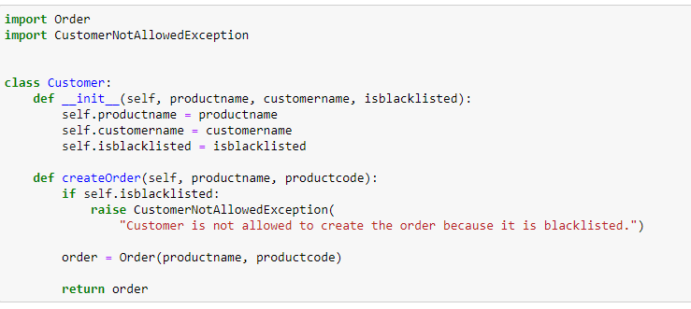

6. Create Custom Exception –Customer Not Allowed Exception

